Helen (Mailand) Scheumann
September 3, 1890 – October 8, 1972

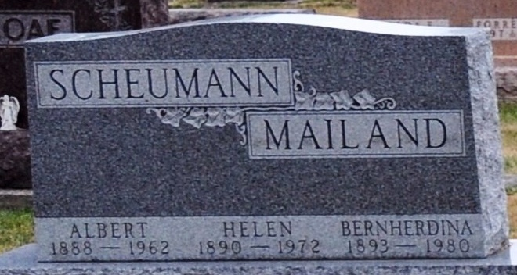
Photo of Deb Curry

Helen Scheumann Dies at Hospital
Mrs. Helen Scheumann, 82, of Decatur route 1, Marion Township, Allen County, died at 5:45 p.m. Sunday at the Adams County Memorial Hospital. She had been in failing health for several years.
She was born in Allen County Sept. 3, 1890, a daughter of Ferdinand and Mary Hormann Mailand, and was married to Albert Scheumann Oct. 17, 1917. Her husband, who died Oct. 18, 1962, was cashier of the Old Adams County Bank for a number of years.
Mrs. Scheumann was a member of the St. John Lutheran Church (Bingen), and the Marion Homemakers club for many years.
Surviving are one daughter, Mrs. Robert (Marjorie) Meyer of Decatur route 1; one sister, Miss Bernherdina Mailand of Decatur route 1; and two granddaughters.
Funeral services will be conducted at 1:30 p.m. Wednesday at the Zwick Funeral Home, with Rev. James T. Hoppes officiating. Burial will be in the Decatur Cemetery. Friends may call at the funeral home after 7 p.m. today until time of the services.
Decatur Daily Democrat, Adams County, Indiana
Monday, October 9, 1972

