Albert Scheumann
February 7, 1888 – October 18, 1962

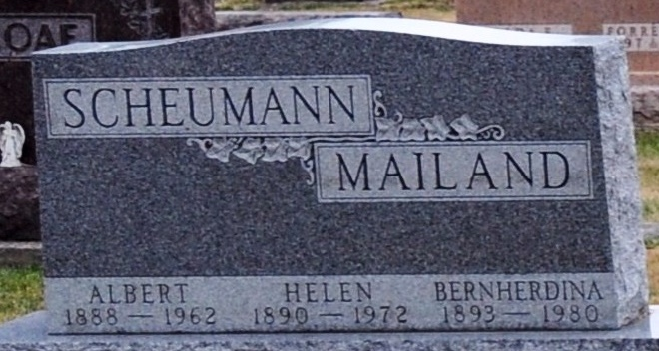
Photo of Deb Curry

Albert Scheumann
in the Indiana, U.S., Death Certificates, 1899-2017
Name Albert Scheumann
Gender Male
Race White
Age 74
Marital Status Married
Birth Date 7 Feb 1888
Birth Place Indiana
Death Date 18 Oct 1962
Death Place Decatur, Adams, Indiana, USA
Death Registration Date 1962
Father Henry Scheumann
Mother Anna Dirksen
Informant Helen Scheumann; wife; Decatur, Indiana
Burial: October 21, 1962; Decatur Cemetery; Decatur, Indiana

