Wilma M. (Cowan) Schenck
February 22, 1876 – October 22, 1939

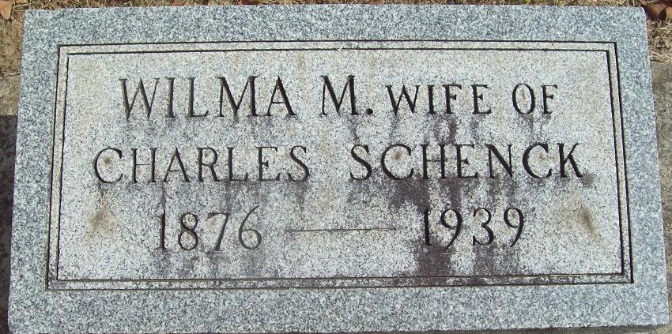
Photo by Alicia Kneuss

LONG ILLNESS PROVES FATAL
Mrs. Charles Schenck, Sister of County Residents; Funeral Tuesday

Mrs. Charles Schenck, 63, of St. Mary's Township, Adams County, Ind., died Sunday morning at St. Joseph Hospital in Fort Wayne. She had been ill with complications for two years.
A daughter of John and Amy Daily Cowan, she was born February 22, 1876 in Adams County. She was a member of Pleasant Mills Methodist Church.
Surviving are her husband; four children, John Schenck of Decatur, Ind., Miss Margaret Schenck of Mishawaka, Ind., Mrs. L. A. Younkman of Lafayette, O., and Mrs. Merle Ellenberger of Jackson, O.; four brothers, H. B. Cowan of East Sycamore Street, J. D. Cowan of Willshire, Dr. J. C. Cowan of New Haven, Ind., and E. H. Cowan of Tacoma, Wash.; two sisters, Mrs. Brice McMillen of Decatur, Ind., and Mrs. H. D. Roop of Los Angeles, Calif.; and four grandchildren.
Funeral services will be held Tuesday at 1:30 p.m. (CST) at Pleasant Mills Methodist Church. Burial will be in Decatur Cemetery. The body will be removed from the Cowan Funeral Home to the family home Monday.

Van Wert Times Bulletin; Van Wert County, Ohio
Monday, October 23, 1939

