Margaret C. Schenck
March 11, 1906 – April 6, 1999

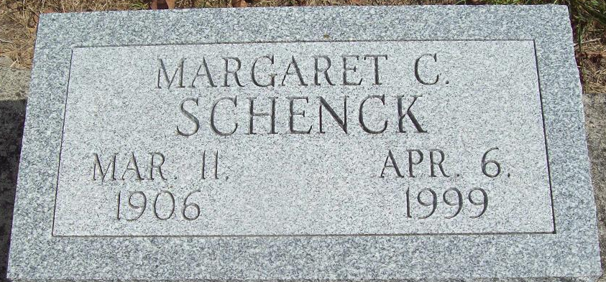
Photo by Alicia Kneuss

MISHAWAKA – Margaret C. Schenck, 93, of North Cedar Street, died Tuesday in St. Paul's Retirement Community, South Bend.
Survivors include two sisters, Helen Younkman of Harrod, Ohio, and Amy Ellenberger of Jackson, Ohio.
Services will be at 11 a.m. Saturday in Hahn Funeral Home, where friends may call one hour before services. A committal service will be at 2:30 p.m. Saturday at Maplewood Cemetery, Decatur, Ind.

South Bend Tribune, Elkhart County, Indiana
Thursday, April 8, 1999

**
Indiana, U.S., Death Certificates, 1899-2017
Name Margaret C. Schenck
Gender Female
Race White
Age 93
Marital Status Never Married (Single)
Birth Date 11 Mar 1906
Birth Place Decatur, Indiana
Death Date 6 Apr 1999
Death Place Mishawaka, St Joseph, Indiana, USA
Death Registration Date 1999
Father Charles Dwight Schenck
Mother Wilma Cowan
Informant: Rosalie Portolese; POA; Mishawaka, Indiana
Burial: April 10, 1999; Maplewood Cemetery; Decatur, Indiana

