Grace Gertrude Schenck
August 10, 1874 – April 20, 1943

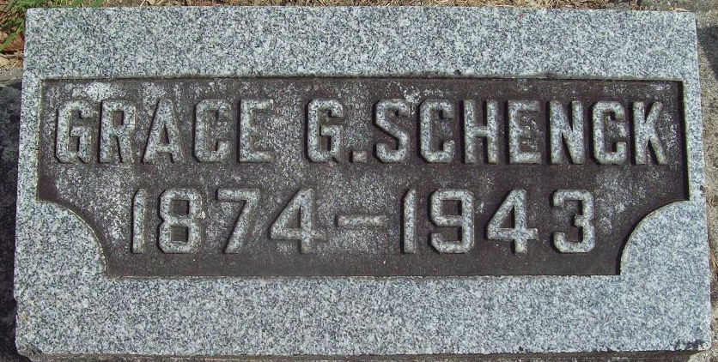
Photo by Alicia Kneuss

Grace Gertrude Schenck
in the U.S., Newspapers.com™ Obituary Index, 1800s-current
Name Grace Gertrude Schenck
Gender Female
Death Age 68
Birth Date 10 Aug 1874
Birth Place In-Wiltshire, Ohio
Residence Place Decatur, Indiana
Death Date 20 Apr 1943
Obituary Date 22 Apr 1943
Obituary Place Bartlett, Nebraska, USA
Newspaper Title Wheeler County Independent
Father: D. J. Schenck
Parents D.j.; Fordyce Schenck
Siblings: Charles, John, [No Name] W. Fishbsugh, Margaret Campbell of Bartlett, Ells Schenck.. Harve Schenck, D. J. Schenck

