Rev. Daniel James Schenck
April 5, 1833 – February 27, 1909

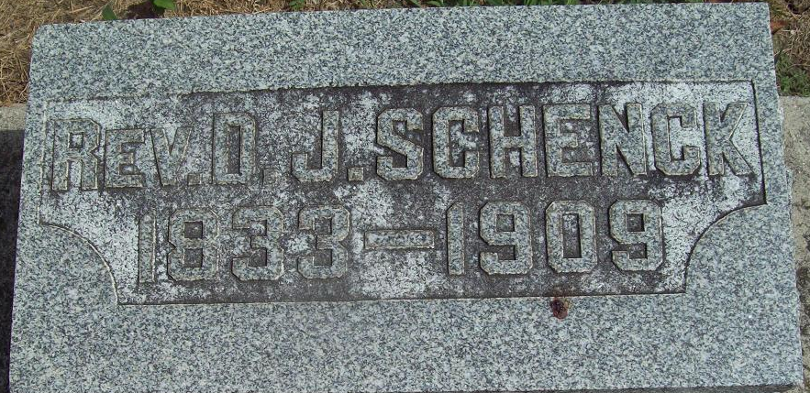
Photo by Alicia Kneuss

Rev D P Schenck
in the Indiana, U.S., Death Certificates, 1899-2017
Name Rev D J Schenck
Gender Male
Race White
Age 75
Marital Status Married
Birth Date 5 Apr 1833
Birth Place Minister
Death Date 27 Feb 1909
Death Place Decatur, Adams, Indiana, USA
Death Registration Date 1909
Father David Schenck
Mother Lydia Meiers
Informant: Amanda Schenck; Decatur, Indiana
Burial: March 1, 1909; Maplewood Cemetery

