Daniel James “Rolla” Schenck
August 6, 1886 – March 24, 1917

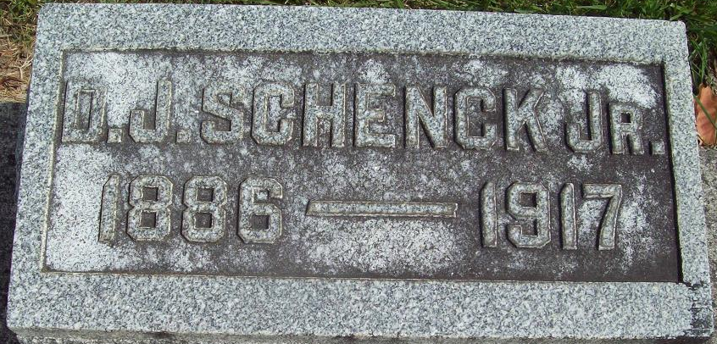
Photo by Alicia Kneuss

DIED IN DETROIT
Rolla Schenck, Son of Mrs. Amanda Schenck, Died Suddenly
IN DETROIT, MICHIGAN
Body Will Be Brought to Mother's Home - Well Known Here

Rolla Schenck, aged about 30 years, died Saturday near midnight in Detroit, Mich. The body will be brought this evening at 9 o'clock to the home of his mother, Mrs. Amanda Schenck, who resides in St. Mary's Township, near Pleasant Mills.
The news of the death came very unexpectedly to his relatives here. Details were not given but the impression is that his death followed an operation for appendicitis.
The deceased was married less than a year ago to Miss Katherine Gordon of Bluffton.
A brother, Charles Schenck, accompanied by Mr. Cowan of Willshire, O., left at once for Detroit to bring back the body.
The wife, the mother, the brother, Charles Schenck, and two sisters, Grace, at home and Mrs. Curtis Campbell of Bluffton, are the immediate relatives he leaves.

Decatur Daily Democrat; Adams County, Indiana
Monday, March 26, 1917
**
Rolo D J Schank in Myers, Puncheon, Beckett,Wolf tree
Spouse Cathrine Gordon
Father Rev Daniel James Schenck
Mother W. Amanda Fordyce
Birth 6 Aug 1886 Indiana, USA
Death 24 Mar 1917 Detroit, Wayne, Michigan, USA
Residence 1910 Adams, Indiana, USA

