Amanda Wood (Fordyce) Schenck
August 20, 1844 – March 10, 1929

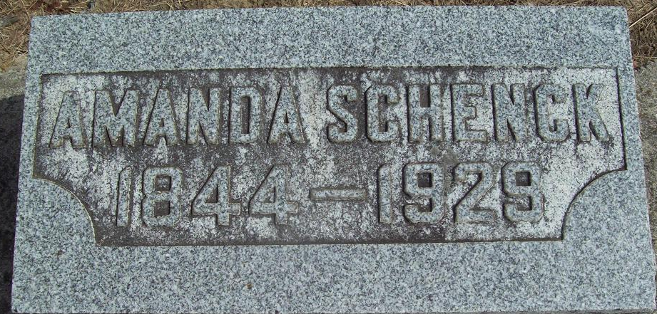
Photo by Alicia Kneuss

Amanda W Schenck
in the Indiana, U.S., Death Certificates, 1899-2017
Name Amanda W Schenck
[Amanda W Fordyce]
Gender Female
Race White
Age 84
Marital Status Widowed
Birth Date 20 Aug 1844
Birth Place Ohio
Death Date 10 Mar 1929
Death Place Saint Marys, Adams, Indiana, USA
Death Registration Date 1929
Father John Fordyce
Mother Mary Brown
Spouse Daniel D Schenck
Informant: C. D. Schenck; Decatur, Indiana
Burial: March 13, 1929; Decatur, Indiana

