Oley M. (Hill) Scheimann
May 30, 1884 – September 25, 1968

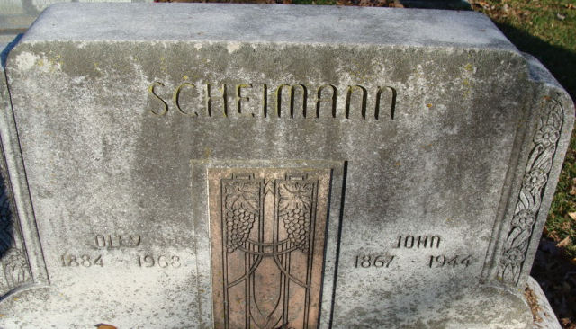
Photo by Alicia Kneuss

Oley M Scheimann
in the Indiana, U.S., Death Certificates, 1899-2017
Name Oley M Scheimann
[Oley M Hill]
Gender Female
Race White
Age 84
Marital Status Widowed
Birth Date 30 May 1884
Birth Place Indiana
Death Date 25 Sep 1968
Death Place Decatur, Adams, Indiana, USA
Death Registration Date 1968
Father Drayton Hill
Mother Eva Sheehan
Informant Fred Scheimann; son; Kokomo, Indiana
Burial: September 29, 1968; Decatur Cemetery; Decatur, Indiana

