Nira Shirley (Miller) Scheimann
January 23, 1935 – September 8, 1999

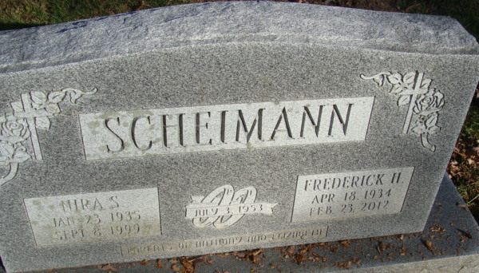
Photo by Alicia Kneuss

Nira S. Scheimann, 64, of Ossian, a native of Decatur, died Wednesday, Sept. 8, 1999, at University of Kentucky Medical Center in Lexington, Ky. She worked for Anne's Hallmark Shop in Covington Plaza, Fort Wayne, and was a member of Mount Calvary Lutheran Church in Fort Wayne.
Surviving is her husband, Fred; a son, Anthony L. of Vancleave, Miss.; a daughter, Elizabeth A. Scheimann of Simpsonville, S.C.; sisters Sandy Clem and Bobbie Jo Rothgeb, both of Monroeville, and Vickie French of Fort Wayne; and three grandchildren. Her sister, Belva Strickler, preceded her in death.
Services are 10 a.m. Saturday at Mount Calvary Lutheran Church, Fort Wayne, with calling one hour before services. Calling is also from 2 to 5 and 6 to 8 p.m. Friday at Zwick & Jahn Funeral Home, Decatur. Burial will be in Decatur Cemetery.
Memorials are to the church.

News-Sentinel, Allen County, Indiana
Thursday, September 9, 1999

**
U.S., Social Security Applications and Claims Index, 1936-2007
Name Nira Shirley Miller
[Nira Shirley Scheimann] [Fred Scheimann] [Nira Scheimann]
Gender Female
Race White
Birth Date 23 Jan 1935
Birth Place Decatur, Indiana
[Decatur Adam??, Indiana]
Death Date 8 Sep 1999
Father Orland C Miller
Mother Helen I May
SSN xxx
Notes Aug 1948: Name listed as NIRA SHIRLEY MILLER; Jul 1953: Name listed as NIRA SHIRLEY SCHEIMANN; : Name listed as FRED SCHEIMANN; 16 Sep 1999: Name listed as NIRA S SCHEIMANN

