John F. Scheimann, Jr.
July 27, 1906 – April 6, 1940

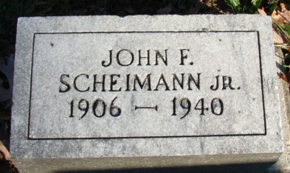
Photo by Alicia Kneuss

SCHEIMAN

Decatur, Apr. 6 – John Scheiman, Jr., 33, lifelong resident of Decatur and former chemist at the Central Sugar Company here for 13 years, died at 3:50 pm today at the home of his parents, Mr. and Mrs. John Scheiman of this city.
Surviving is the widow, Mrs. Margaret Scheiman; two sons, Johnny and Freddy; the parents and three brothers, George Scheiman of Fort Wayne, Bernard Scheiman of Gibson City, Ill., and Albert Fred Scheiman of this city.
Funeral services will be held Wednesday at 1:30 pm at the residence and at 2 pm at Zion Lutheran Church here, with Rev. P. W. Schultz officiating. The Zwick Funeral Home is in charge of arrangements.
Journal-Gazette, Allen County, Indiana
April 7, 1940
**

Handwritten date: Monday, April 8, 1940

YOUNG DECATUR MAN DECEASED
Johnny Scheimann, Jr. Dies Saturday After Long Illness

Johnny Scheimann, Jr., 33, well known Decatur young man, died Saturday afternoon at 3:50 o'clock at the home of his parents, 1501 Patterson Street. Death was attributed to complications, following an illness of five months. He had been seriously ill for the past 10 days.
The deceased was born in Decatur, July 27, 1906, the son of Mr. and Mrs. John Scheimann, Sr. He was married to Margaret Elliott June 30, 1930.
Scheimann served as chemist at the local sugar factory for 13 years and later operated a service station at the corner of Thirteenth and Adams streets. He also assisted his father, a local livestock dealer. He was a member of the Zion Lutheran church in this city.
Surviving besides the widow are two children, Johnny, 8, and Freddie, 5. the parents, and four brothers, George of Fort Wayne, Bernard of Gibson City, Illinois, Albert and Fred of Decatur. A sister is deceased.
Funeral services will be held Wednesday afternoon at 1:30 o'clock at the home and 2 o'clock at the Zion Lutheran Church, with Rev. Paul W. Schultz officiating. Burial will be in the Decatur Cemetery. The body was returned to the residence from the Zwick Funeral Home this afternoon and may be viewed there until time for the services.

Adams County Historical Museum, Adams County, Indiana
February – December 1940 Scrapbook

**
Indiana, U.S., Death Certificates, 1899-2017
Name Johnny Schaman
Gender Male
Race White
Age 33
Marital Status Married
Birth Date 27 Jul 1906
Birth Place Decatur
Death Date 6 Apr 1940
Death Place Decatur, Adams, Indiana, USA
Death Registration Date 1940
Father John Scheiman Sr.
Mother Oley Hill
Spouse Margaret Elliott; age 26
Informant: Mrs. Johnny Scheiman; Decatur, Indiana
Burial: April 10, 1940; Decatur Cemetery; Decatur, Indiana

