John Scheimann
November 18, 1867 – May 2, 1944

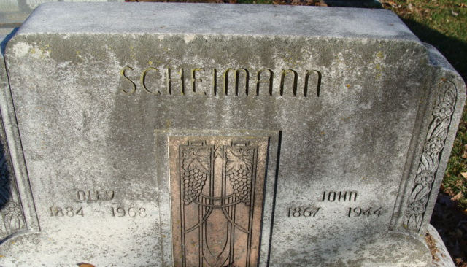
Photo by Alicia Kneuss

John Scheiman
in the Indiana, U.S., Death Certificates, 1899-2017
Name John Scheiman
Gender Male
Race White
Age 76
Marital Status Married
Birth Date 18 Nov 1867
Birth Place Decatur Adams Co, Indiana
Death Date 2 May 1944
Death Place Decatur, Adams, Indiana, USA
Death Registration Date 1944
Father Frederick Scheiman
Mother Caroline Koldewey
Spouse Oley Hill; age 59
Informant: Mrs. John Scheiman; Decatur, Indiana
Burial: May 5, 1944; Decatur Cemetery; Decatur, Indiana

