Frederick W. C. Scheimann
August 8, 1874 – March 11, 1913

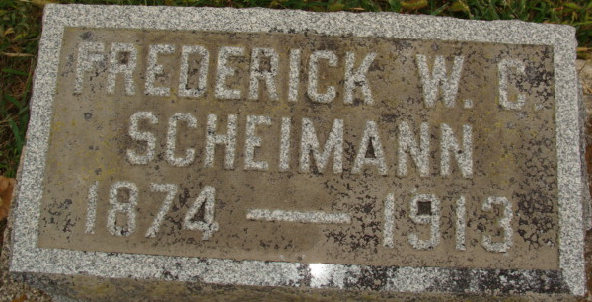
Photo by Alicia Kneuss

Fred Scheimann
Death • Ohio Deaths, 1908-1953

Name Fred Scheimann
Sex Male
Age 38
Birth Date 08 Aug 1874
Birthplace Ind.
Burial Date 11 Mar 1913
Burial Place Decatur, Ind.
Marital Status Married
Race W
Father's Name Fred Scheimann
Father's Sex Male
Father's Birthplace Germany
Mother's Name Caroline Koldeway
Mother's Sex Female
Mother's Birthplace Germany
Event Type Death
Event Date 10 Mar 1913
Event Place Cincinnati, Hamilton, Ohio
Informant: ? Scheimann; Decatur, Indiana
Source Details fn 15621

