Frederick H. Scheimann
April 18, 1934 – February 23, 2012

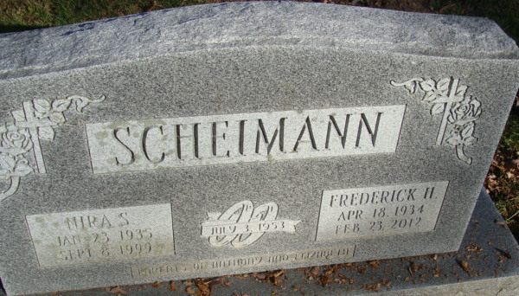
Photo by Alicia Kneuss

Frederick “Fred” H. Scheimann, 77 years old, widower of Nira Shirley Miller Scheimann, died Thursday, February 23, 2012 at his residence after an extended illness. Fred was born in Decatur, Indiana; he was the son of the late John L. and Margaret J. (Elliott) Scheimann.
Fred retired from Union Carbide and was a member of Immanuel Lutheran Church in Simpsonville, South Carolina. Fred was an avid fisherman and farmer, but his true love was playing cards with his friends at the Simpsonville Senior Center.
Surviving is a daughter, Beth (John) Scheimann-Parker of Simpsonville, SC; a son, Tony Scheimann of Vancleave, MS; a brother, John Scheimann; and two grandchildren, Shane and Joshua Scheimann. In addition to his parents and wife, he was preceded in death by a grandson, Dustin Scheimann.
Visitation will be held Saturday, February 25, 2012 from 1:30 p.m. until 2:45 p.m. at Immanuel Lutheran Church, 2820 Woodruff Road, Simpsonville, South Carolina with the funeral service following at 3:00 p.m. in the church. Friends will also be received on Tuesday, February 28, 2012 from 1-3 p.m. at the Zwick and Jahn Funeral Home, Decatur, Indiana followed by a Graveside Service at the Decatur Cemetery in Decatur, Indiana with Rev. Peter Brock officiating.
Memorials may be made to Immanuel Lutheran Church, 2820 Woodruff Road, Simpsonville, SC 29681 or Greenville Humane Society, 305 Airport Road, Greenville, SC 29607.

Zwick & Jahn Funeral Home, Adams County, Indiana
February 24, 2012

**
Indiana, U.S., Birth Certificates, 1907-1944
Name Harold Frederick Scheimann
Gender Male
Birth Date 18 Apr 1934
Birth Place Decatur, Adams, Indiana, USA
Father John F Scheimann; age 27
Mother J Margaret Elliott; age 20; 2nd child, both living
Certificate Number 12402
Roll number 40474_357177
Volume Range 21 - 25
**
U.S., Cemetery and Funeral Home Collection, 1847-Current
Name Frederick Scheimann
Gender Male
Death Age 77
Birth Date 1935
Birth Place Decatur, in
Death Date 23 Feb 2012
Burial Place Decatur, Indiana
Obituary Date 31 Oct 2019
Parents John L. Scheimann; Margaret J. Elliott Scheimann
Spouse: Nira Shirley Miller Scheimann
Child: Beth Scheimann-Parker, Tony Scheimann

