Ruth Virginia (Amstutz) Scheiman
March 22, 1918 - April 23, 2010
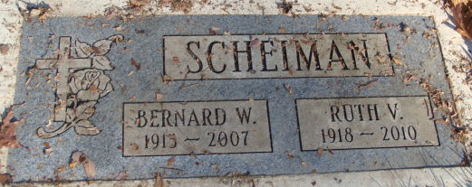
Photo by Alicia Kneuss
Ruth Scheiman, 92, of Bradenton, formally of Ellenton, died April 23, 2010.
Services will be held up north at a later date. Brown & Sons Funeral Home & Crematory, 26th Street Chapel, is in charge.
Survivors include her niece, Lois Anzini of Sabastian, and several other nieces and nephews.

Pasadena Herald Tribune, Pasadena, California
April 28, 2010

**
U.S., Obituary Collection, 1930-Current
Name Ruth Virginia Scheiman
Gender Female
Death Age 92
Birth Date 22 Mar 1918
Residence Place Bradenton, Ellenton
Death Date 23 Apr 2010
Obituary Date 28 Apr 2010
**
Virginia, U.S., Marriage Records, 1936-2014
Name Ruth Virginia Amstutz
Gender Female
Race White
Marriage Age 21
Birth Date abt 1916
Marriage Registration Place Warren, Virginia, USA
Marriage Date 23 Jul 1937
Marriage Place Keezletown, Virginia, USA
Father William Amstutz
Mother Sophia Zbinden
Spouse Bernard William Scheiman
Certificate Number 1937016728

