Paul W. Scheiman
June 5, 1909 – May 4, 1995

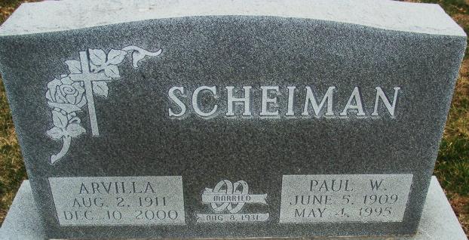
Photos by Alicia Kneuss

PAUL W. SCHEIMAN

Paul W. Scheiman, 85, Fort Wayne, a former resident of Adams County, died at 12:04 p.m. Thursday in St. Joseph's Medical Center. He was a resident of Lutheran Home for the past several years.
He was born on June 5, 1909 in Columbia City to Henry and Emma Hockemeyer Scheiman and married Arvilla Bieberich on August 8, 1931. She survives.
He was a retired employee of the Martin Marietta Corp. in Denver, Colorado and a member of St. Peter Lutheran Church, rural Adams County, and the Lutheran Laymen's League.
The only other survivor is a daughter, Mrs. Harvey (Delores) Tesch, Tucson, Arizona. A son, Robert Scheiman; a sister; two brothers and a grandson are deceased.
Funeral services will be at 1 p.m. Sunday in St. Peter Lutheran Church, with burial in Decatur Cemetery. Visitation is 1-2 p.m. Saturday in Lutheran Home; 5-7 p.m. Saturday in Zwick-Sefton and Jahn Funeral Home, Decatur; and noon-1 p.m. Sunday in the church.
Preferred memorials are to Lutheran Homes Inc., or "The Lutheran Hour".

Decatur Daily Democrat, Adams County, Indiana
Friday, May 5, 1995

