Bernard William Scheiman
November 25, 1915 – June 1, 2007

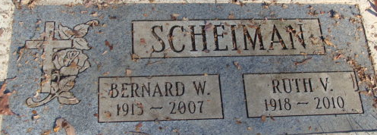
Photo by Alicia Kneuss

Bernard W Scheiman
in the U.S., Newspapers.com™ Obituary Index, 1800s-current
Name Bernard W Scheiman
Gender Male
Death Age 93
Birth Date 25 Nov 1913
Birth Place Decatur, Indiana, USA
Residence Place Bradenton, Manatee, Florida, USA
Death Date 1 Jun 2007
Obituary Date 5 Jun 2007
Obituary Place Bradenton, Florida, USA
Newspaper Title The Bradenton Herald
Spouse Rufii
**
Virginia, U.S., Marriage Records, 1936-2014
Name Bernard William Scheiman
Gender Male
Race White
Marriage Age 23
Birth Date abt 1914
Marriage Registration Place Warren, Virginia, USA
Marriage Date 23 Jul 1937
Marriage Place Keezletown, Virginia, USA
Father John Scheiman
Mother Oley Hill
Spouse Ruth Virginia Amstutz
Certificate Number 1937016728

