Arvilla (Bieberich) Scheiman
August 2, 1911 – December 10, 2000

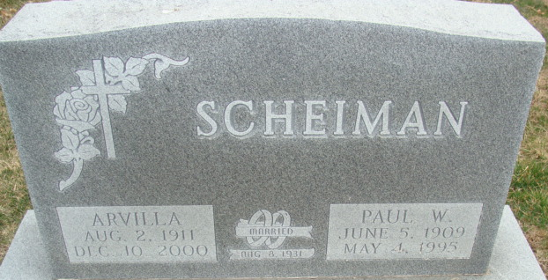
Photos by Alicia Kneuss

Arvilla Scheiman, 89, of Fort Wayne, a member of St. Peter Lutheran Church-Fuelling, died Sunday, Dec. 10, 2000, at Lutheran Homes. The Decatur native was a homemaker.
Surviving is a daughter, Delores Tesch of Tucson, Ariz. She was preceded in death by her husband, Paul W., and a son, Robert.
Services are 10:30 a.m. Friday at Zwick & Jahn Funeral Home, Decatur, with calling from 6 to 8 p.m. Thursday. Calling is also from 1 to 3 p.m. Thursday at Lutheran Homes Chapel, 6701 S. Anthony Blvd. Burial will be at Decatur Cemetery.
Memorials are to Lutheran Home or the church.

News-Sentinel, Allen County, Indiana
Tuesday, December 12, 2000

**
Indiana, U.S., Death Certificates, 1899-2017
Name Arvilla Scheiman
[Arvilla Bieberich]
Gender Female
Race White
Age 89
Marital Status Widowed
Birth Date 2 Aug 1911
Birth Place Decatur Indiana
Death Date 10 Dec 2000
Death Place Fort Wayne, Allen, Indiana, USA
Death Registration Date 2000
Father Adolph Bieberich
Mother Clara Schueler
Informant: Delores Tesch; daughter; Tucson, Arizona
Burial: December 15, 2000; Decatur Cemetery; Decatur, Indiana

