Viola M. (Dyer) Scheiderer
May 31, 1895 – December 30, 1991

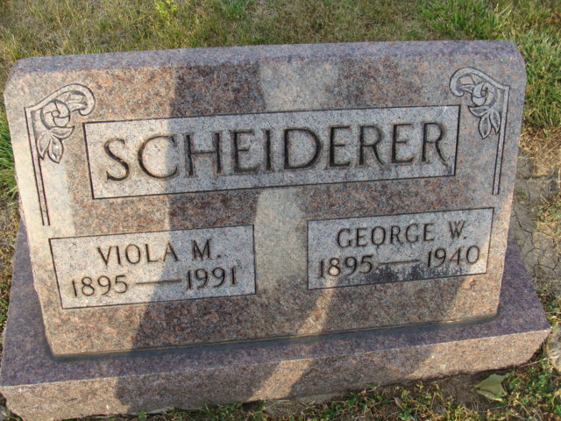
Photo by Alicia Kneuss

M Viola Scheiderer
in the Indiana, U.S., Death Certificates, 1899-2017
Name M Viola Scheiderer
[M Viola Dyer]
Gender Female
Race White
Age 96
Marital Status Widowed
Birth Date 31 May 1895
Birth Place Kenton Ohio
Death Date 30 Dec 1991
Death Place New Haven, Allen, Indiana, USA
Death Registration Date 1991
Father Theotis Dyer
Mother Mathilda Preadmore
Informant: Fred Scheiderer; son; Decatur, Indiana
Burial: January 2, 1992; Decatur Cemetery; Decatur, Indiana

