Melba L. (Kraft) Scheiderer
May 11, 1919 – June 18, 2000

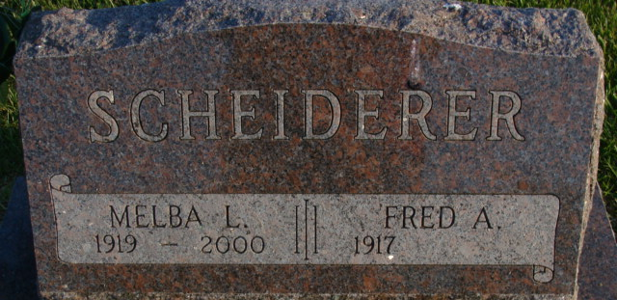
Photo by Alicia Kneuss

Melba Scheiderer, 81, of Decatur, a homemaker, died Sunday, June 18, 2000, at Lutheran Hospital, Fort Wayne. The Spencerville, Ohio, native was a member of First United Church of Christ and had worked at Adams Central School cafeteria.
Surviving is her husband, Fred; daughters Madge Harman of Claypool and Glenda Inniger of Decatur; sons Allen of Geneva and Duane of Lexington, Ky.; 11 grandchildren; and 14 great-grandchildren. She was preceded in death by her sisters, Phyllis Barnum, Ava Liechty and Donna Tickle.
Services are 2 p.m. Wednesday at Zwick & Jahn Funeral Home, Decatur, with calling one hour before services and also from 3 to 8 p.m. Tuesday. Burial will be at Decatur Cemetery.
Memorials are to Diabetes Association or Zion United Church of Christ scholarship fund.

News-Sentinel, Allen County, Indiana
Monday, June 19, 2000

**
Indiana, U.S., Death Certificates, 1899-2017
Name Melba Scheiderer
[Melba Kraft]
Gender Female
Race White
Age 81
Marital Status Married
Birth Date 11 May 1919
Birth Place Spencerville, Ohio
Death Date 18 Jun 2000
Death Place Fort Wayne, Allen, Indiana, USA
Father Harman F. Kraft
Mother Lois M. Townsend
Spouse Fred A. Scheiderer
Informant: Fred Scheiderer; husband; Decatur, Indiana
Burial: June 21, 2000; Decatur Cemetery; Decatur, Indiana

