George W. Scheiderer
February 17, 1895 – October 21, 1940

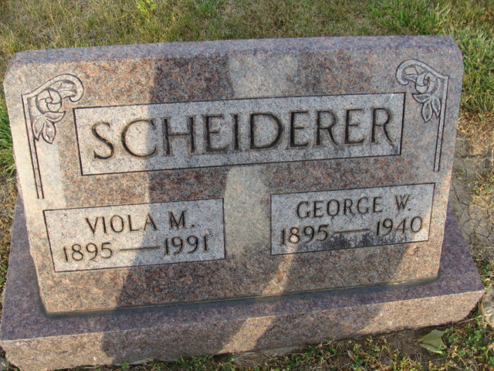
Photo by Alicia Kneuss

Adams County Man is Suicide
(Special to the Journal-Gazette) Decatur, October 21 - George W. Scheiderer, 45, committed suicide at 5:45 pm today by shooting himself with a 12-guage shotgun at his home in Root Township, five miles northeast of this city. He received the full discharge of the gun in the head.
The shooting occurred in the kitchen of his home while other members of his family were outside the house. No motive for his act was known. L. L. Yager, of Berne, acting coroner of Adams County, said his verdict would be suicide.
The body was brought to the Zwick Funeral Home here. Funeral arrangements are incomplete.
Surviving is the widow, Mrs. Viola Dyer Scheiderer and two sons, Arthur and Fred at home.
Journal-Gazette, Allen County, Indiana
October 22, 1940
**
Indiana, U.S., Death Certificates, 1899-2017
Name George W Scheiderer
Gender Male
Race White
Age 45
Marital Status Married
Birth Date 17 Feb 1895
Birth Place Marysville, Union County, Ohio
Death Date 21 Oct 1940; suicide by gun shot
Death Place Rural, Adams, Indiana, USA
Death Registration Date 1940
Father Christopher Scheiderer
Mother Frederica Kleeber
Spouse Viola Dyer; age 45
Informant: Arthur Scheiderer; Decatur, Indiana
Burial: October 24, 1940; Decatur Cemetery; Decatur, Indiana

