Fred A. Scheiderer
February 17, 1917 – September 11, 2012

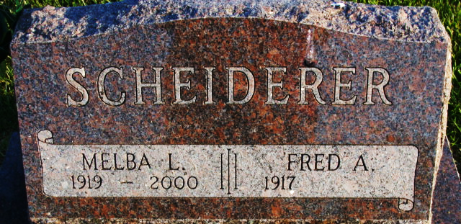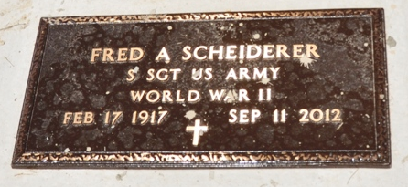
Photo by Deb Curry

Fred A. Scheiderer, 95 years old of Decatur, Indiana, passed away on Tuesday, September 11, 2012 at Adams Memorial Hospital. He was born on Saturday, February 17, 1917 in Kenton, Ohio the son of the late George W. Scheiderer and the late Matilda Viola (Dyer) Scheiderer. He married Melba L. Kraft on February 17, 1938 and she passed away on June 18, 2000.
Fred served in the United States Army during World War II; where he was stationed in Hamburg, Germany. He was a member of the Zion United Church of Christ in Decatur. Fred retired from Home Dairy in Berne, Indiana with over twenty-four years of service.
Surviving is his daughter, Madge Harman of Claypool, Indiana; son, Allen (Alice) Scheiderer of Fort Wayne, Indiana; daughter, Glenda Inniger of Decatur, Indiana; son, Duane (Denise) Scheiderer of Lexington, Kentucky; eleven grandchildren; twenty-four great-grandchildren; and seven great great-grandchildren.
Preceding Fred in death was a brother, Arthur Scheiderer.
Private family services will be held and there will be no visitation.
Preferred memorials are to the donor's choice.

Zwick & Jahn Funeral Home, Adams County, Indiana
September 12, 2012
**
Indiana, U.S., Death Certificates, 1899-2017
Text Only

Name Fred A Scheiderer
Gender Male
Race White
Age 95
Birth Date 17 Feb 1917
Birth Place Kenton, Ohio
Death Date 11 Sep 2012
Death Place Decatur, Adams, Indiana, USA
Death Registration Date 2012
Father George W Scheiderer
Mother Matilda Viola Dyer
Certificate Number 040693

