Faye K. (Martin) Scheiderer
June 20, 1919 – December 8, 1988

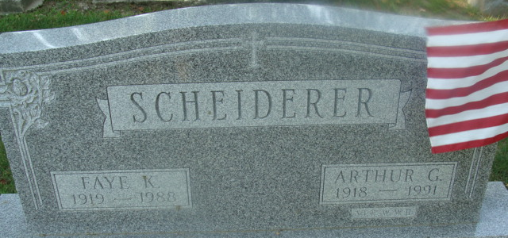
Photo by Alicia Kneuss

Faye K Scheiderer
in the Indiana, U.S., Death Certificates, 1899-2017
Name Faye K Scheiderer
[Faye K Martin]
Gender Female
Race White
Age 69
Marital Status Married
Birth Date 20 Jun 1919
Birth Place Decatur, Indiana
Death Date 8 Dec 1988
Death Place Woodburn, Allen, Indiana, USA
Death Registration Date 1988
Father Frank O Martin
Mother Sarah M Arnold
Spouse Arthur Scheiderer
Informant: Arthur Scheiderer; husband; Woodburn, Indiana
Burial: December 12, 1988; Decatur Cemetery; Decatur, Indiana

