Arthur George Scheiderer
May 3, 1918 – June 4, 1991

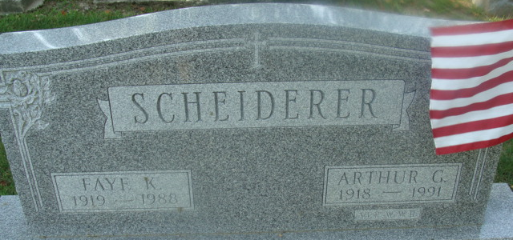
Photo by Alicia Kneuss

Arthur George Scheiderer
in the Indiana, U.S., Death Certificates, 1899-2017
Name Arthur George Scheiderer
Gender Male
Race White
Age 73
Marital Status Widowed
Birth Date 3 May 1918
Birth Place Kenton, Ohio
Death Date 4 Jun 1991
Death Place Woodburn, Allen, Indiana, USA
Death Registration Date 1991
Father George Scheiderer
Mother Matilda V
Informant: Paul Scheiderer; son; Woodburn, Indiana
Burial: June 7, 1991; Decatur Cemetery; Decatur, Indiana

