Richard G. Schauss
April 15, 1924 – August 6, 1973

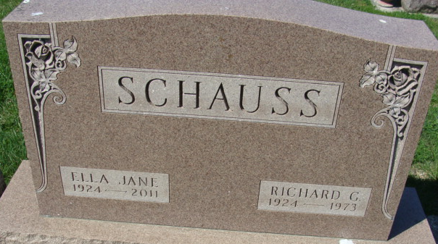
Photo of Alicia Kneuss

Richard G. Schauss, 49, stricken while watching son play baseball

Richard G. Schauss, 49, 419 Limberlost Trail, Decatur, prominent Decatur resident and employee of Central Soya since 1955, died Monday evening after suffering a heart attack while watching his youngest son play in a little League All-Star game at Leo. He was pronounced dead on arrival at Parkview Memorial Hospital in Fort Wayne at 9:45 p.m.
Schauss, who was general purchasing agent for the engineering department at Central Soya headquarters in Fort Wayne, was an avid sports fan and the father of three boys, all strong competitors in community athletic competitions. He was active in various community affairs, including the annual Community Fund drive.
His son, Craig, 12, was a member of the Decatur Little League All-Star team competing in the Leo tournament Monday evening, while his eldest son, John, 17, and Rick, 15, excelled in sports for Bellmont Junior and Senior High Schools.
Schauss was born April 15, 1924 at Norwalk, Ohio, the son of John and Lela Boch-Schauss, who preceded him in death. He was married December 20, 1952 to the former Jane Richardson, who survives.
He was a member of the First Presbyterian Church in Decatur, and a veteran of World War II, having served in India with the U.S. Army Corps of Engineers. Schauss was graduated from Kent State University in 1955 and began his service with Central Soya soon afterwards…
Surviving with the wife and three sons is a sister, Mrs. Allen (Peggy) Beckloff of Rosemont, Pa. Four brothers preceded him in death.
Funeral services will be conducted at 1:30 p.m. Thursday at the Zwick Funeral Home in Decatur, the Rev. Robert VanderHart officiating. Burial will follow in Decatur Cemetery. Friends may call at the funeral home after 11 a.m. Wednesday until time of the services.

Decatur Daily Democrat, Adams County, Indiana
Tuesday, August 7, 1973

