Ella Jane (Richardson) Schauss
November 17, 1924 – November 11, 2011

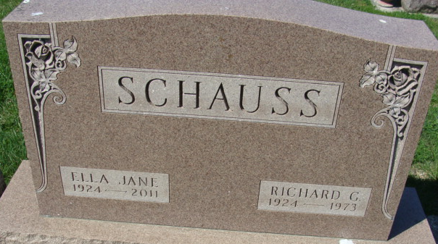
Photo of Alicia Kneuss

Ella Jane (Richardson) Schauss, age 86, passed away at 10:33 a.m. on Friday, November 11, 2011 at Estelle's House of Marion County Hospice in Ocala, Florida. She had moved to Ocala in June of 2004 after having lived in Decatur, Indiana.
She loved her family. She also enjoyed reading, watching sports, spending hours at the beach, and watching and identifying birds and butterflies in her Florida garden.
Jane was born on November 17, 1924, in East Liverpool, Ohio to Guy Richardson and Grace (Gaston) Richardson. Because her parents raised cantaloupes and other seasonal produce, she spent her winters in Ocala, Florida and her summers in Ontario, Indiana which were central to the family-owned packing houses.
She received her BS from Wooster College in Ohio and her MA from St. Francis College in Fort Wayne, Indiana. Her 30-year teaching career began in Ohio in Carrolton, Rootstown, and Norwalk public schools. She retired from North Adams Community Schools in Decatur, Indiana where she taught English at Bellmont High School and served as Language Arts department chairperson.
While living in Decatur, Indiana, Jane was a member of the First Presbyterian Church in Decatur, the Delta Kappa Gamma Sorority, Decatur Women's Club, the Research Club, and Indiana Retired Teachers Association.
Jane was married to Richard G. Schauss on December 20, 1952 in Norwalk, Ohio and he preceded her in death on August 6, 1973.
Jane is survived by her three sons: John A. (Joan) Schauss of Richmond, Virginia; Rick J. (Beth) Schauss of Greens Fork, Indiana; and Craig A. (Krista) Schauss of Hilton Head, South Carolina; six grandchildren: Mark Schauss, Ryan Schauss, Andrew Schauss, Matthew Schauss, Kayla Schauss, and Adam Schauss.
In addition to her parents and husband, Jane was also preceded in death by two brothers: James "Jimmy" Richardson and William "Billy" Richardson.
Funeral services for Jane will be held at 12 Noon on Wednesday, November 23, 2011 at the Zwick & Jahn Funeral Home, Decatur with Pastor Marcia Cline officiating. Burial will follow at Decatur Cemetery, next to her husband. Friends and family will be received two hours prior to services on Wednesday at the funeral home.
Preferred Memorials are to the First Presbyterian Church, Decatur.
Ocala Star-Banner, Ocala, Florida
November 19, 2011

**
Ella Jane Schauss, age 86, passed away at 10:33 a.m. on Friday, November 11, 2011 at Estelle's House of Marion County Hospice in Ocala, Florida. She had moved to Ocala in June of 2004 after having lived in Decatur, Indiana. She loved her family. She also enjoyed reading, watching sports, spending hours at the beach, and watching and identifying birds and butterflies in her Florida garden.
Jane was born on November 17, 1924, in East Liverpool, Ohio to Guy Richardson and Grace (Gaston) Richardson. Because her parents raised cantaloupes and other seasonal produce, she spent her winters in Ocala, Florida and her summers in Ontario, Indiana which were central to the family-owned packing houses.
She received her BS from Wooster College in Ohio and her MA from St. Francis College in Fort Wayne, Indiana. Her 30-year teaching career began in Ohio in Carrolton, Rootstown, and Norwalk public schools. She retired from North Adams Community Schools in Decatur, Indiana where she taught English at Bellmont High School and served as Language Arts department chairperson.
While living in Decatur, Indiana, Jane was a member of the First Presbyterian Church in Decatur, the Delta Kappa Gamma Sorority, Decatur Women's Club, the Research Club, and Indiana Retired Teachers Association.
Jane was married to Richard G. Schauss on December 20, 1952 in Norwalk, Ohio and he preceded her in death on August 6, 1973.
Jane is survived by her three sons: John A. (Joan) Schauss of Richmond, Virginia; Rick J. (Beth) Schauss of Greens Fork, Indiana; and Craig A. (Krista) Schauss of Hilton Head, South Carolina; 6 Grandchildren: Mark Schauss, Ryan Schauss, Andrew Schauss, Matthew Schauss, Kayla Schauss, and Adam Schauss.
In addition to her parents and husband, Jane was also preceded in death by two brothers: James "Jimmy" Richardson and William "Billy" Richardson.
Funeral services for Jane will be held at 12 Noon on Wednesday, November 23, 2011 at the Zwick & Jahn Funeral Home, Decatur with Pastor Marcia Cline officiating. Burial will follow at Decatur Cemetery, next to her husband. Friends and family will be received 2 hours prior to services on Wednesday at the funeral home.
Preferred Memorials are to the First Presbyterian Church, Decatur.

Decatur Daily Democrat, Adams County, Indiana
November 12, 2011

