Wilma Vacie (Rutherford) Schamerloh
September 9, 1922 – July 6, 2008

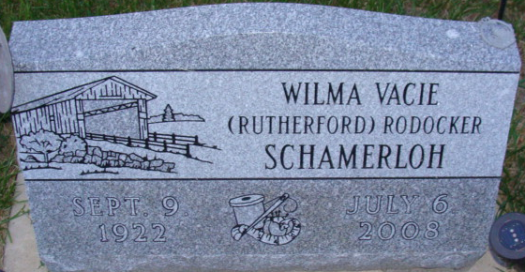
Photos by Alicia Kneuss

Wilma V. (Rutherford) Rodocker-Schamerloh, 85, of Columbia City, passed away Sunday, July 6, 2008, 5:35 a.m., due to a stroke. Born Sept. 9, 1922, in Huntington County, she was the daughter of the late William Henry Rutherford and Mary Forney (Pugh) Rutherford.
She attended Spencerville High School, Spencerville, Ind. She spent her lifetime in Huntington and DeKalb Counties, Hicksville, Ohio, Fort Wayne, and the past five years at Miller's Merry Manor, Columbia City.
She was a seamstress and drapery maker. She volunteered at the Allen County Public Library in the Genealogy Department.
Survivors include her son, Robert C. (Nina) Rodocker of Columbia City; daughter, Carma J. Lucatero of Denver, Colo.; sisters, Nona R. (Harold) Harris of Huntington, and Lou Ann Brown of Richmond, Va.; brother, Thomas N. (LuAnn) Rutherford of New Haven; seven grandchildren; and 17 great-grandchildren. She was also preceded in death by her husbands, William Rodocker and Arthur Schamerloh; sister, Lois F. Fisher; and brother, William H. Rutherford.
Graveside service is 11 a.m. Tuesday, Sept. 9, 2008, at Decatur Cemetery, Decatur, with the Reverend Michael Courtney officiating.
Memorial bequests may be given to Gideon's International or Lighthouse Free Methodist Building Fund.

News-Sentinel, Allen County, Indiana
Sunday, July 13, 2008

**
Wilma V. Schamerloh, 85, of Columbia City, Indiana, died there of a stroke on July 6.
Among survivors are one son, one daughter, two sisters, and one brother. She was married twice, but both husbands are deceased: William Rodocker and Arthur Schamerloh, who was from Decatur.
There will be a graveside funeral service at 11 a.m. on Tuesday, September 9, in Decatur Cemetery.

Decatur Daily Democrat, Adams County, Indiana
Tuesday, July 15, 2008

**
Indiana, U.S., Death Certificates, 1899-2017
Name Wilma Vacie Schamerloh
Maiden Name Rutherford
Gender Female
Race White
Age 85
Marital Status Widowed
Birth Date 9 Sep 1922
Birth Place Huntington, Indiana
Death Date 6 Jul 2008
Death Place Columbia, Whitley, Indiana, USA
Death Registration Date 2008
Father: William Henry Rutherford
Mother: Mary Forney Pugh
Informant: Robert Rodocker; son; Columbia City, Indiana
Cremation: Northern Indiana Crematory; Fort Wayne, Indiana

