Helen Ruth (Plumb) Schaffer
October 19, 1929 – July 2, 2011

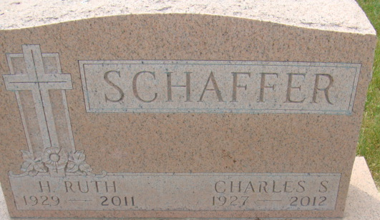
Photo by Alicia Kneuss

Helen Ruth Schaffer, 81 years old and a longtime resident of Decatur, Indiana, passed away on Saturday, July 2, 2011 in Markle Health & Rehabilitation, where she had been a patient for the past 2 1/2 years.
She was born on Saturday, October 19, 1929 in Chalmers, Indiana the daughter of the late Earl Plumb and the late Virginia (Bryant) Plumb. She married Charles S. Schaffer on March 25, 1950 in Decatur, Indiana.
Ruth was a member of the First Baptist Church in Decatur, Indiana and she was a homemaker.
Surviving is her husband, Charles S. Schaffer of Decatur, daughter, Mrs. Myron (Linda) Hamrick of Decatur, grandson, Michael (Melissa) Hamrick of Decatur, granddaughter, Julie (Rev. Dave) Yinger of Terre Haute, grandson, Myron C. Hamrick of Decatur, and four great-grandchildren; Justin, Ashley, Cameron & Lathyn Hamrick.
Preceding Helen in death were one brother, William Charles Plumb and one sister, Olive Marie Plumb.
Funeral services will be held at 11:00 a.m. Thursday, July 7, 2011 in the Zwick & Jahn Funeral Home with Chaplin Annette Baker officiating. Interment will follow in the Decatur Cemetery. Friends will be received from 2-4 and 5-8 p.m., Wednesday, July 6 in the Zwick & Jahn Funeral Home, Decatur.
Preferred memorials are to First Baptist Church, Family Hospice & Palliative Care in Berne or Alzheimer's Research.

Zwick & Jahn Funeral Home, Adams County, Indiana
July 3, 2011

