Carl W. Schaffer
August 22, 1903 – November 4, 1965

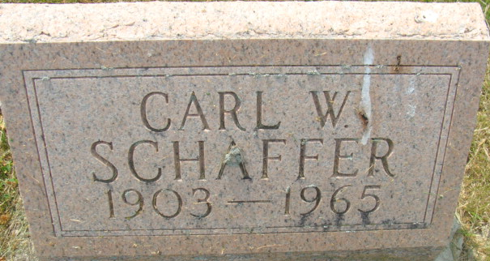
Photo by Alicia Kneuss

Carl W Schaffer
in the Indiana, U.S., Death Certificates, 1899-2017

Name Carl W Schaffer
Gender Male
Race Caucasian (White)
Age 62
Marital Status Divorced
Birth Date 22 Aug 1903
Birth Place Indiana
Death Date 4 Nov 1965
Death Place Fort Wayne, Allen, Indiana, USA
Death Registration Date 1965
Father: Fred Schaffer
Mother: Mary Smith
Informant: Charles S. Schaffer; son; Decatur, Indiana
Burial: November 6, 1965; No. Salem Cemetery; Decatur, Indiana

**
Indiana, U.S., Marriages, 1810-2001

Name Carl Schaffer
Gender Male
Race White
Event Type Marriage Registration (Marriage)
Birth Place Decatur, Adams, Indiana
Marriage Date 19 Aug 1922
Marriage Place Decatur, Indiana, United States
Residence Place Decatur, Adams, Indiana
Father: Fred Schaffer
Mother: Mary Smith
Spouse: Myrtle Bailer
Page 146
FHL Film Number 002321469

