Vida (Stoneburner) Schafer
October 31, 1889 – March 3, 1924

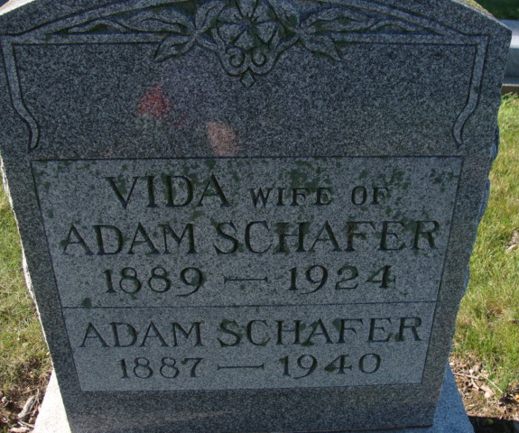
Photo by Alicia Kneuss
Vida Schafer
in the Indiana, U.S., Death Certificates, 1899-2017
Name Vida Schafer
[Vida Stoneburner]
Gender Female
Race White
Age 34
Marital Status Married
Birth Date 31 Oct 1889
Birth Place Adams Co Indiana
Death Date 3 Mar 1924
Death Place Decatur, Adams, Indiana, USA
Death Registration Date 1924
Father: Abraham Stoneburner
Mother: Rachel Johnson
Spouse: Adam Schafer
Informant: Adam Schafer; Decatur, Indiana
Burial: March 5, 1924; Decatur Cemetery

