Sarah A. (Weimer) Shafer
September 10, 1855 – August 4, 1938

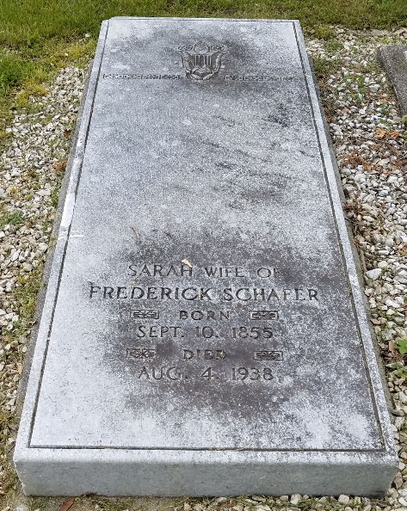
Photo by Alicia Kneuss

DEATH CLAIMS MRS. SCHAFER
Mrs. Fred Schafer Dies Thursday Evening at Marion, Ohio
Mrs. Fred Schafer, 82, widow of the late Fred Schafer, pioneer hardware merchant, and mother of Chalmer C. Schafer of this city, died at 7 o'clock Thursday evening at the Sawyer Hospital, Marion, Ohio.
Death was due to complications and infirmities. Two weeks ago, Mrs. Schafer fell and fractured her left leg. She had been in poor health for some time and had been a patient at the hospital for an extended period.
Mrs. Schafer was born September 10, 1855, just beyond the Adams County line, in Van Wert County, Ohio, the daughter of George and Martha Weimer. Her father was fatally wounded in the Civil war and the mother and her two daughters moved to Decatur.
On November 2, 1876, she was married to Fred Schafer of this city. Mr. Schafer's parents lived on a farm south of Decatur, now owned and known as the Adams County Infirmary farm. Mr. Schafer became a leading merchant in Decatur. His death occurred in 1932, following an accident.
Besides the son, one sister, Mrs. J. B. Meibers of Fort Wayne, survives. Three grandchildren and two great grandchildren in this city also survive.
The body was brought here this (cut off)

Decatur Daily Democrat, Adams County, Indiana
Friday, August 5, 1938
**
Collection: Ohio Deaths 1908-1953
Name: Sarah Schafer
Death date: 04 Aug 1938
Death place: Marion, Marion, Ohio - Sawyer Sanitorium
Birth date: 10 Sep 1855; Birth place: Pa.
Age at death: 82 years 11 months 7 days
Gender: Female; Marital status: Widowed; Race or color: Caucasian
Street address: Decatur, Ind. 3 Ward; Occupation: Home
Residence: Marion, Marion, Ohio
Burial date: 06 Aug 1938; Cemetery name: Decatur Cem.
Father name: Geo. Weimer b. PA; Mother maiden name: unknown Informant: Robert J. Zwick of Decatur, IN (Zwick also held funeral)
GSU film number: 2023613; Digital GS number: 4019326
Image number: 194; Reference number: fn 47872

**
Sarah B. Weimer in Adams-Peterson Family Tree
Spouse Fredric Schafer
Father George Weimer
Mother Martha Jane Niblick
Children Chalmer Christen
Birth 10 Sep 1855 Adams, Indiana, USA
Death 4 Aug 1938 Ohio, USA
Residence 1870 Wabash, Indiana, USA

