Richard F. Schafer
April 28, 1921 – January 26, 1982

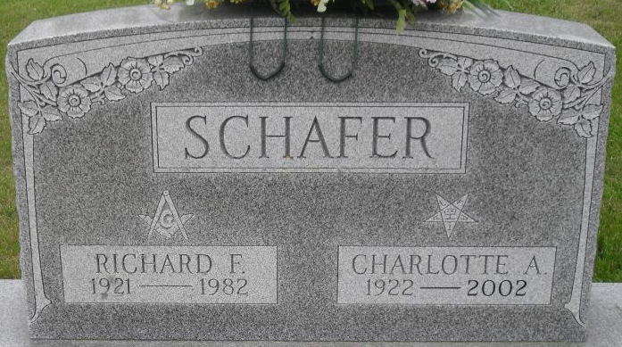
Photo by Stephen & Andrea Brangan

Richard F. Schafer
in the Indiana, U.S., Death Certificates, 1899-2017
Name Richard F. Schafer
Gender Male
Race White
Age 60
Marital Status Married
Birth Date 28 Apr 1921
Birth Place Indiana
Death Date 26 Jan 1982
Death Place Fort Wayne, Allen, Indiana, USA
Death Registration Date 1982
Father: Carl Schafer
Mother: Irene Eady
Spouse: Charlotte Andrews
Informant: Mrs. Richard Schafer; Decatur, Indiana
Burial: January 29, 1982; Decatur Cemetery; Decatur, Indiana

