Jacob Schafer
February 2, 1852 – March 8, 1936

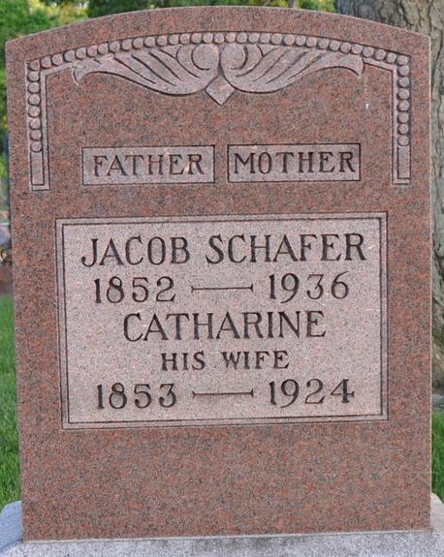
Photo by Deb Curry

Jacob Schaffer
in the Indiana, U.S., Death Certificates, 1899-2017
Name Jacob Schaffer
Gender Male
Race White
Age 84
Marital Status Widowed
Birth Date 2 Feb 1852
Birth Place Germany
Death Date 8 Mar 1936
Death Place Decatur, Adams, Indiana, USA
Death Registration Date 1936
Father: Jacob Schaffer
Mother: Mary Brown
Spouse: Catherine
Informant: Adam Schaffer
Burial: March 10, 1936; Decatur Cemetery

