Irene D. (Eady) Schafer
April 14, 1897 – May 5, 1979

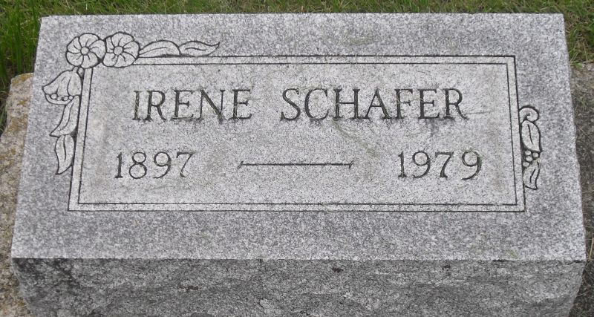
Photo by Stephen & Andrea Brangan

Irene D. Schafer
in the Indiana, U.S., Death Certificates, 1899-2017
Name Irene D. Schafer
[Irene D. Eady]
Gender Female
Race White
Age 82
Marital Status Widowed
Birth Date 14 Apr 1897
Birth Place Indiana
Death Date 5 May 1979
Death Place Decatur, Adams, Indiana, USA
Death Registration Date 1979
Father: Jacob Eady
Mother: Rebecca Fisher
Informant: Richard Schafer; Decatur, Indiana
Burial: May 8, 1979; Decatur Cemetery; Decatur, Indiana

