Grayce Birch (Daniel) Shafer
March 6, 1882 – April 9, 1925

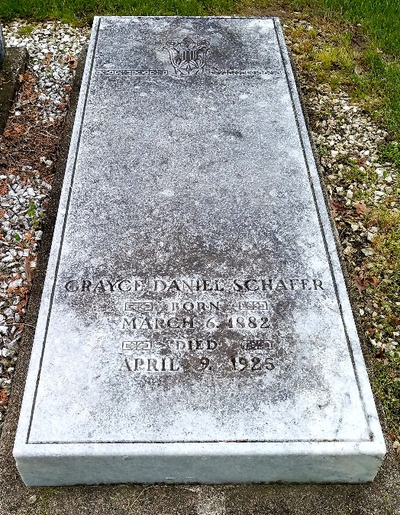
Photo by Alicia Kneuss

MRS. C. C. SCHAFER DIES EARLY TODAY AFTER OPERATION
Death Unexpected as She Appeared to Rally Following Operation –
WAS WELL KNOWN - Resident of Decatur Most Of Her Life
Funeral Services Saturday
The Angel of death touched the brow of Mrs. Chalmer C. Schafer at 2:10 o'clock this morning and her spirit passed into eternity, ending the suffering which she has endured for many months. While it was known that her condition was serious, it was believed until late last evening that she would recover from the operation performed at the St. Joseph Hospital, Fort Wayne, yesterday morning and the announcement of the change came as a terrible shock to the members of the family who had returned here for the night. They hurried to Fort Wayne and arrived an hour and a half before the end came. Mrs. Schafer recovered nicely from the anesthetic and talked with her nurse and physician early in the evening, indicating that she had an excellent chance for at least temporary recovery, but her system, weakened by her long illness, seemed to suddenly give away and death followed in a few hours.
Mrs. Schafer first became ill last summer with liver and pancreas trouble. November 20 last, she entered the Adams County Memorial Hospital and two days later underwent a major operation. For several weeks her life hung by a thread, but her splendid nerve carried her through and she had almost entirely recovered when about a month ago she again began to suffer She was treated by Fort Wayne and Decatur physicians and it was finally decided Monday evening that an operation should be performed as the only chance to relieve her. For a while yesterday it was the opinion of all that she would recover, but a turn for the worse came last evening and all that loving hands and skilled physicians could do was unavailing. She slept peacefully away, surrounded by her loved family and mother at 2:10 this morning.
The sad news has shocked and depressed this community where Mrs. Schafer was so well known.
The deceased was born at Columbia City, Indiana, March 6, 1882, the daughter of Rev. and Mrs. William H. Daniels. Her father, a pastor and a presiding elder of the Methodist Church, died in this city in February, 1908. Her maiden name was Grace Birch Daniels. She was educated in the public schools at Richmond and Decatur, Indiana, and later attended Ohio Wesleyan college at Delaware, Ohio. She came to this city with her parents in 1898 and has resided here since that time. January 1, 1900, she was united in marriage to Mr. Chalmer C. Schafer, of the Schafer Company, one of the best-known businessmen of the city. To them were born three children, one daughter, Miss Gretchen; and two sons, Frederick and Daniel. Surviving relatives are the husband and children, the mother, Mrs. Emma Daniels and one brother, Mr. Harry Daniels of New York City.
Mrs. Schafer had traveled much and was a constant reader, well informed on every subject and a splendid woman, a loving mother and a devoted wife. When seven years old she united with the Methodist Church and had taken a large part in Sunday school work. She was a member of the Ladies' Shakespeare Club of this city, the Eastern Star Lodge and the Delta Theta Tan Sorority. She was one of the most popular women of this community, of kindly disposition and lovely manner.
Funeral services will be held from the home on North Second Street at two o'clock Saturday afternoon, Rev. U. S. A. Bridge of the Methodist Church officiating. The casket will not be open at the services. Friends desiring to view the remains may do so at the residence, Friday afternoon from three to five o'clock and from eight to nine o'clock in the evening. Burial will take place at the Decatur Cemetery.

Decatur Daily Democrat, Adams County, Indiana
Thursday, April 9, 1925
**
Indiana, U.S., Death Certificates, 1899-2017
Name Mrs Grace Schafer
[Mrs Grace Daniels]
Gender Female
Race White
Age 43
Marital Status Married
Birth Date 6 Mar 1882
Birth Place Columbia City, Indiana
Death Date 9 Apr 1925
Death Place Fort Wayne, Allen, Indiana, USA
Father: Rev Wm Daniels
Mother: Emma S Birch
Spouse: Chalmer Schafer
Informant: Mr. C. C. Schafer; Decatur, Indiana
Burial: April 11, 1925; Decatur Cemetery

