Frederick Shafer
February 7, 1851 – October 25, 1931

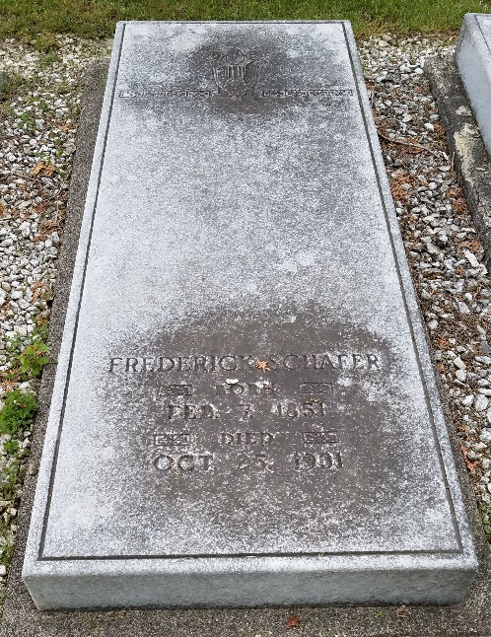
Photo by Stephen & Andrea Brangan

Frederic Schofer
in the Indiana, U.S., Death Certificates, 1899-2017
Name Frederic Schafer
Gender Male
Race White
Age 80
Marital Status Married
Birth Date 10 Sep 1851(sic)
Birth Place: Tuscarawas County, Ohio
Death Date 25 Oct 1931
Death Place Indiana, Adams, Indiana, USA
Death Registration Date 1931
Father: Christian Schafer
Mother: Catherine
Spouse: Sarah D.
Informant: Chalmer Schafer; Decatur, Indiana
Burial: October 28, 1931; Decatur, Indiana

