Charlotte A. (Andrews) Schafer
March 14, 1922 – July 10, 2002

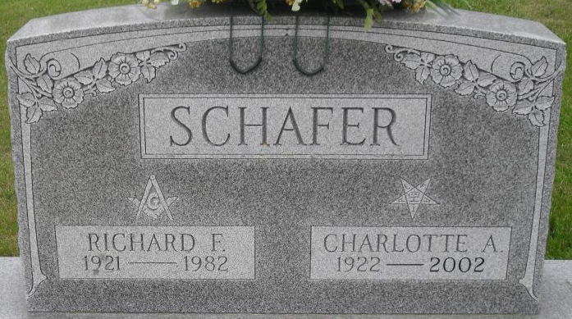
Photo by Stephen & Andrea Brangan

Charlotte A. Schafer, 80, of Decatur, a member of Zion United Church of Christ and Eastern Star, died Wednesday, July 10, 2002, at Adams County Memorial Hospital. The Warren, Ohio, native retired in 1979 from the North Adams Community Schools cafeteria.
Surviving are sons William A. Schafer of Churubusco, and Robert D. of Siloam Springs, Ariz.; sisters Evelyn Bedwell and Joan Andrews, both of Fort Wayne, and Geraldine McConnell of Decatur; eight grandchildren; and eight great-grandchildren. She was preceded in death by her husband, Richard F., a brother and three sisters.
Services are 11 a.m. Saturday at Haggard & Sefton Funeral Home, Decatur, with calling from 2 to 4 and 6 to 8 p.m. today. Burial will be at Decatur Cemetery.
Memorials are to the church or Bi County Services.
News-Sentinel, Allen County, Indiana
July 12, 2002
**
Indiana, Death Certificates, 1899-2011
Name: Charlotte A Schafer
[Charlotte A Andrews]
Gender: Female
Race: White
Age: 80
Marital status: Widowed
Birth Date: 14 Mar 1922
Birth Place: Warren Ohio
Death Date: 10 Jul 2002
Death Place: Decatur, Adams, Indiana, USA
Father: Charles Andrews
Mother: Stella Barber
Informant: William A. Schafer, son
Burial: July 13, 2002, Decatur Cemetery

