Chalmer C. Schafer
January 4, 1878 – August 3, 1947

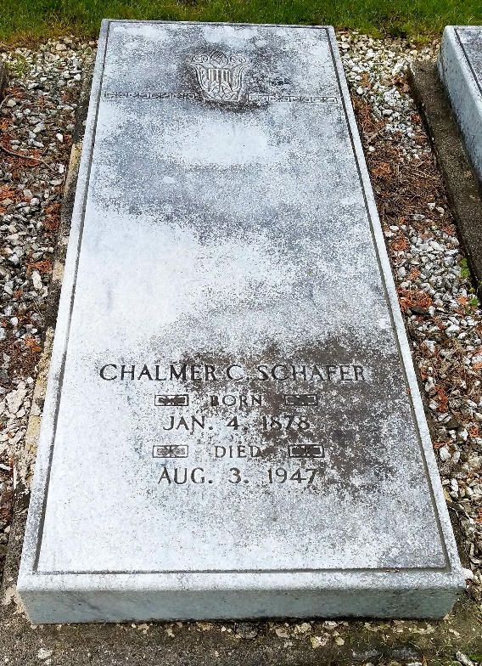
Photo by Alicia Kneuss

C. C. SCHAFER IS DEAD AFTER LONG ILLNESS
Prominent Decatur Businessman Dies Sunday Afternoon
Funeral services for Chalmer C. Schafer, 69, civic and business leader of this city and president of the Schafer enterprises here, will be held at 9:30 o'clock Wednesday morning at his home, 2313 Forest Park Boulevard, Fort Wayne. Burial will be in the Decatur Cemetery.
The services will be conducted by the Rev. S. J. Cross, a retired Methodist minister of Shelbyville and father of Mrs. Schafer. The funeral cortege is expected to arrive at the cemetery about 11 o'clock.
Mr. Schafer died Sunday afternoon at his Fort Wayne residence of a cerebral hemorrhage, following a two years' illness.
The son of Mr. and Mrs. Fred W. Schafer, Mr. Schafer was born in Decatur. His father, who died in 1931, was one of the first hardware merchants in this city.
He graduated from the Decatur High School in 1897 and later attended Culver Military Academy and Indiana University. He then embarked on his business career with his father in the hardware store. In 1912, he founded The Schafer Company, a wholesale hardware and harness manufacturing concern, which during the first World War period and up until a few years ago manufactured a line nationally known as Black Beauty harness.
The company's plant of West Washington street was destroyed by fire in 1920. Undaunted by the disaster, Mr. Schafer built a new building on First Street, adjoining other Schafer properties, and expanded his business. World War II found the company turning out thousands of pairs of leather gloves for the armed forces.
Following the death of his father, Mr. Schafer directed the expansion of the Schafer retail store and with his sons and co-workers developed it into Decatur's largest mercantile establishment.
Closely identified with all civic and business projects in this city, Mr. Schafer served enthusiastically in the development of Decatur. With his energy and vision, he served on the earlier Chamber of Commerce and Industrial club committees, that lent themselves to the establishing of new industries in this city. Among these was the committee that staged the "greater Decatur" program through a real estate sale. Later, he was an enthusiastic member of a group who assisted in the selection of this city as the home of the state's first beet sugar processing plant. He was a member of those committees that cooperated in the location of the General Electric plant and later in the establishment of the McMillen Industries here.
Mr. Schafer was a member of the Methodist Church. Fraternally, he was a charter member of the Decatur B. P. O. Elks. He was a former member of the Decatur Masonic Lodge and thirty-second degree Mason. He was a member of Phi Kappa Psi Fraternity, the Fort Wayne Country Club and the Fort Wayne Horse Show Association.
Mr. Schafer is survived by his wife, Ruth; two sons, Frederic and Daniel, both identified with the Schafer enterprises; one daughter, Mrs. William H. Bell of this city, and three grandchildren.
The body will be removed to the Schafer residence, where friends may call after 7:30 o'clock this evening.
The Schafer Store and the Schafer company will be closed all day Wednesday, it was announced.

Decatur Daily Democrat, Adams County, Indiana
Monday, August 4, 1947

**
Indiana, U.S., Death Certificates, 1899-2017
Name Chalmer C Schafer
Gender Male
Race White
Age 69
Marital Status Married
Birth Date 4 Jan 1878
Birth Place Decatur Indiana
Death Date 3 Aug 1947
Death Place Fort Wayne, Allen, Indiana, USA
Death Registration Date 1947
Father: Frederic E Schafer
Mother: Sarah Weimer
Spouse: Ruth; age 47
Informant: Mrs. Ruth Schafer; Fort Wayne, Indiana
Burial: August 6, 1947; Maplewood Cemetery; Fort Wayne, Indiana

