Catharine (Weber) Schafer
May 10, 1853 – November 22, 1924

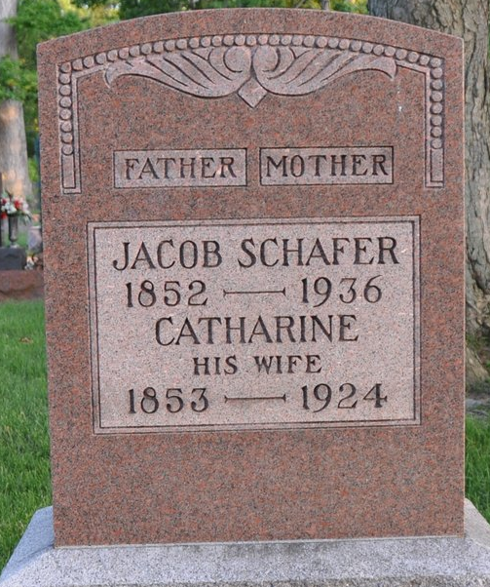
Photo by Deb Curry

DEATH CLAIMS THREE LADIES AT DECATUR
Mrs. Clara Lillian Todd-Ruckman, age 37 years, wife of D. V. Ruckman of Decatur, died at 10:30 o'clock on Friday evening at the Adams County Memorial Hospital of septic poisoning, following the birth of a baby girl baby. She became ill a week ago and was removed to the hospital. Death came a few minutes after the child was born.
The infant lives, and is expected to survive. Besides the husband and the infant, two daughters survive. The funeral was held this afternoon.
Mrs. Jacob Schafer, age 71 years, wife of Jacob Schafer of Decatur, died early Saturday morning following an extended illness of chronic heart trouble. She and her husband are natives of Germany.
Surviving are the aged husband and six children. Funeral services were held this afternoon.
Also early on Saturday morning occurred the death of Mrs. Mary Hill, aged 60 years, at the home of her brother, John Reynolds, in Decatur. After a long illness of chronic asthma and enlargement of the heart, death resulted Saturday. Three brothers and a son survive.
The funeral was held from the Decatur Evangelical church this morning.

Berne Witness, Adams County, Indiana
Monday, November 24, 1924
**

Indiana, Death Certificates, 1899-2011
Name: Catharine Schofer
[Catharine Weber]
Gender: Female
Race: White
Age: 71
Marital status: Married
Birth Date: 10 May 1853
Birth Place: Germany
Death Date: 22 Nov 1924
Death Place: Decatur, Adams, Indiana , USA
Father: Jacob Weber
Spouse: Jacob Schofer
Informant: Jacob Schofer; Decatur, Ind.
Burial: Nov. 24, 1924; Decatur Cem.

