Carl Schafer
February 8, 1889 – June 9, 1932

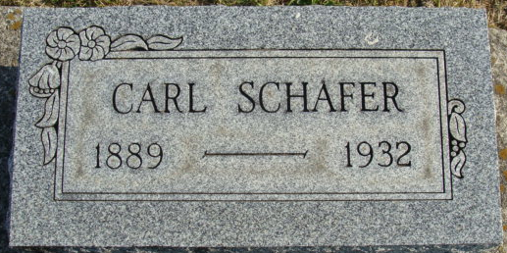
Photo by Alicia Kneuss
Calz Schafer
in the Indiana, U.S., Death Certificates, 1899-2017
Name Carl Schafer
Gender Male
Race White
Age 43
Marital Status Married
Birth Date 8 Feb 1889
Birth Place Wallbalden, Germany
Death Date 9 Jun 1932
Death Place Decatur, Adams, Indiana, USA
Death Registration Date 1932
Father: Jacob Schafer
Mother: Catherine Weber
Spouse: Irene Eady
Informant: Mrs. Irene Schafer; Decatur, Indiana
Burial: June 12, 1932; Decatur Cemetery

