William Earl Scarbrough
April 19, 1899 – February 15, 1975

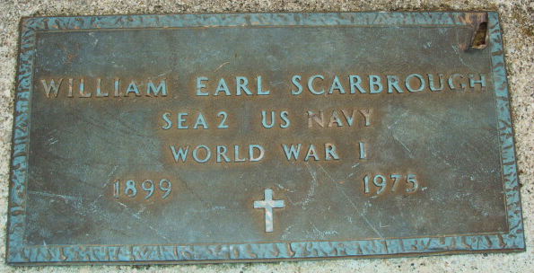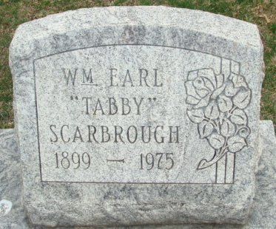
Photo by Alicia Kneuss
W. E. Scarbrough

William Earl (Tabby) Scarbrough, 75, of 716 Elm St., a retired employee of Bag Service, Inc., died at 12:13 p.m. Saturday at the Adams County Memorial Hospital. He had been a patient there for seven days. Mr. Scarbrough retired in 1964 from the Bag Service after 21 years of service. He was a member of American Legion Post 43 and a veteran of World War I, serving in the U.S. Navy.
Born April 19, 1899, in Paxton, Ill., he was the son of William Harrison and Amanda Jane Henline-Scarbrough.
Survivors include the wife, Eveleen of Hollywood, Fla.; seven children, Mrs. John (Florence) Feeney of Pittsburgh, Pa.; Mrs. Roy (Helen) May of Hyattsville, Md.; Mrs. Marvin (Veronica) Fryer of Virginia; Mrs. Edgar (Nancy) Behner of Dallas, Tex.; Mrs. John (Pat) McCarthy of Hollywood, Fla.; Frank Scarbrough of Pittsburgh, Pa.; Thomas Scarbrough of Holly, Fla.; 36 grandchildren and 16 great-grandchildren. Mr. Scarbrough was the last member of a family of seven.
Funeral services will be held at 10:30 a.m. Tuesday at the Zwick Funeral Home, with Rev. Ralph Tomson officiating. Burial will be in the Decatur Cemetery. Friends may call at the funeral home after 2 p.m. today.

Decatur Daily Democrat, Adams County, Indiana
February 17, 1975

