Charles Ellsworth Scaffa
December 11, 1942 – July 1, 1976

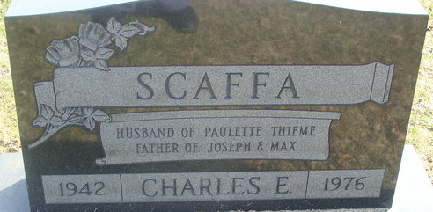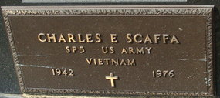
Photos by Alicia Kneuss

Charles Ellsworth Scaffa
in the Indiana, U.S., Death Certificates, 1899-2017
Name Charles Ellsworth Scaffa
Gender Male
Race White
Age 33
Marital Status Married
Veteran: Viet Nam War
Birth Date 11 Dec 1942
Birth Place Indiana
Death Date 1 Jul 1976; homicide
Death Place Fort Wayne, Allen, Indiana, USA
Death Registration Date 1976
Father: Joseph Scaffa
Mother: Darlene Magner
Spouse: Paulette Thieme
Informant: Mrs. Paulette Scaffa; wife; Craigville, Indiana
Burial: July 3, 1976; Decatur Cemetery; Decatur, Indiana

