Leonard C. Saylors
July 28, 1906 – August 16, 1967

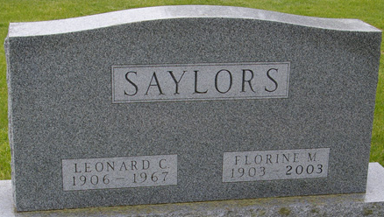
Photo by Corgilover

Leonard C Saylors
in the Indiana, U.S., Death Certificates, 1899-2017
Name Leonard C Saylors
Gender Male
Race White
Age 61
Marital Status Married
Birth Date 28 Jul 1906
Birth Place Emporia Kansas
Death Date 16 Aug 1967
Death Place Fort Wayne, Allen, Indiana, USA
Death Registration Date 1967
Father: Thomas M Saylors
Mother: Edna May Adams
Informant: Florine Saylors; wife
Burial: August 19, 1967; Maplewood Cemetery; Decatur, Indiana

