Florine (Michaud) Saylors
August 19, 1903 – January 15, 2003

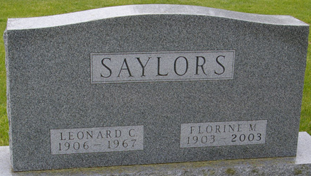
Photo by Corgilover

Florine Saylors, 99, of Fort Wayne and formerly of Decatur died Wednesday, Jan. 15, 2003, at Saint Anne Home. The Berne native had taught school in Decatur and for Fort Wayne Community Schools. She was a member of First Presbyterian Church.
Surviving is a cousin, Kay Yager of Decatur. Her husband, Leonard, preceded her in death.
Services are 2 p.m. Friday at Haggard & Sefton Funeral Home, 225 W. Adams St., Decatur, with calling from noon until services. Burial will be at Decatur Cemetery.

News-Sentinel, Allen County, Indiana
Thursday, January 16, 2003

**
Indiana, U.S., Death Certificates, 1899-2017
Name Florine M Saylors
[Florine M Michaud]
Gender Female
Race White
Age 99
Marital Status Widowed
Birth Date 19 Aug 1903
Birth Place Berne Indiana
Death Date 15 Jan 2003
Death Place Fort Wayne, Allen, Indiana, USA
Death Registration Date 2003
Father: Henry S Michaud
Mother: Lillie M Meshberger
Informant: Kay Yager; cousin; Decatur, Indiana
Burial: January 17, 1900; Decatur Cemetery; Decatur, Indiana

