Kevin R. Saylor
April 20, 1960 – March 13, 1981

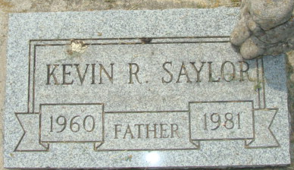
Photo by Alicia Kneuss

Kevin R. Saylor
in the Indiana, U.S., Death Certificates, 1899-2017
Name Kevin R. Saylor
Gender Male
Race White
Age 20
Marital Status Married
Birth Date 20 Apr 1960
Birth Place Indiana
Death Date 13 Mar 1981; suicide by shot gun
Death Place Decatur, Adams, Indiana, USA
Death Registration Date 1981
Father: Carl Saylor
Mother: Phyllis Malone
Spouse: Devota Bleeke
Informant: Mrs. Devota Saylor; Decatur, Indiana
Burial: March 16, 1981; Decatur Cemetery; Decatur, Indiana

