Harold Sautter
July 27, 1898 – February 3, 1948

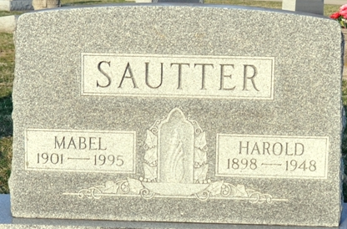
Photos by Deb Curry

Harold Sautter
in the Indiana, U.S., Death Certificates, 1899-2017
Name Harold Sautter
Gender Male
Race White
Age 49
Marital Status Married
Birth Date 27 Jul 1898
Birth Place Marion, Ohio
Death Date 3 Feb 1948
Death Place Decatur, Adams, Indiana, USA
Death Registration Date 1948
Father: Lewis Sautter
Mother: Mildred Baker
Spouse: Mabel
Informant: Mrs. Mabel Sautter; Decatur, Indiana
Burial: February 6, 1948; Decatur Cemetery; Decatur, Indiana

