E. Mabel (Walter) Sautter
July 12, 1901 – March 4, 1995

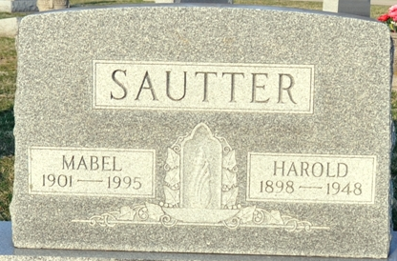
Photos by Deb Curry

E. Mabel Sautter, 93, of Decatur died Saturday in Woodcrest Nursing Home. The Adams County native retired in 1971 from United Telephone Co. after 24 years and was the widow of Harold, who died in 1948.
Surviving is a daughter, Barbara Minich of Monroeville; sisters, Velma Lake and Irene Gattshall, both of Decatur; 10 grandchildren; and 18 great- grandchildren.
Services are 11 a.m. tomorrow in Zion Lutheran Church, Decatur, with burial in Decatur Cemetery. Calling is 2 to 5 and 7 to 9 p.m. today in Zwick, Sefton & Jahn Funeral Home, Decatur.

News-Sentinel, Allen County, Indiana
Monday, March 6, 1995

**
Indiana, U.S., Death Certificates, 1899-2017
Name E Mabel Sautter
[E Mabel Walter]
Gender Female
Race White
Age 93
Marital Status Widowed
Birth Date 12 Jul 1901
Birth Place Adams County, Indiana
Death Date 4 Mar 1995
Death Place Decatur, Adams, Indiana, USA
Death Registration Date 1995
Father: August G Walter
Mother: Anna Knapp
Informant: Barbara Minnich; daughter; Monroeville, Indiana
Burial: March 7, 1995; Decatur Cemetery; Decatur, Indiana

