William O. Sautbine
November 3, 1875 – January 23, 1972

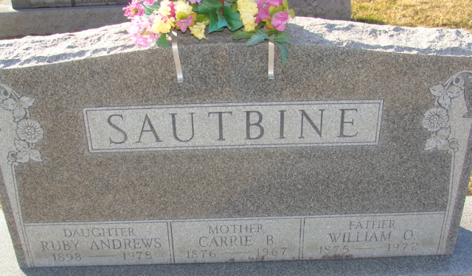
Photo by Alicia Kneuss

William Sautbine Dies at Age 96
William O. Sautbine, 96, of 612 North Third Street, a retired farmer, died at 8 p.m. Sunday at the Berne Nursing Home, Berne, following an extended illness. He was born in Kirkland Township Nov. 3, 1875, a son of Isaac and Elizabeth Bollinger-Sautbine, and was married to Carrie B. Ward in November of 1898. His wife preceded him in death in Aug. 11, 1967.
Mr. Sautbine was a member of St. Mark’s United Methodist Church.
Surviving are one daughter, Mrs. Ruby Andrews of Richmond; four sons, Lewis Sautbine of Bemidji, Minn., Robert Sautbine of Decatur, Herman Sautbine of Portland, and Walter Sautbine of St. Paul, Minn.; one sister, Mrs. Ada Hayburg of Walker, Minn.; 12 grandchildren; 23 great-grandchildren and one great-great-grandchild. Two sisters and four brothers are deceased.
Funeral services will be conducted at 1:30 p.m. Wednesday at the Winteregg-Linn Funeral Home, with Rev. Fuhrman Miller officiating. Burial will be in the Decatur Cemetery. Friends may call at the funeral home after 1 p.m. Tuesday until time of the services.

Decatur Daily Democrat, Adams County, Indiana
Monday, January 24, 1972

