William A. Sautbine
November 6, 1928 – February 2, 2021

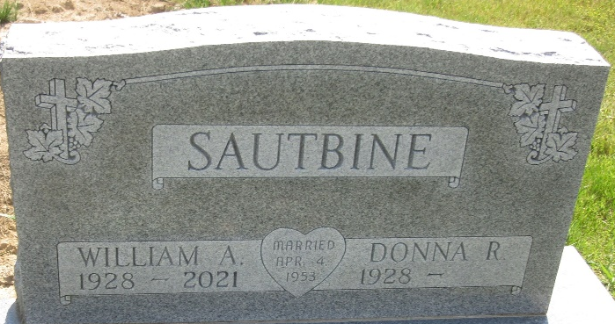
Photo by PLS

William A. "Bill" Sautbine, 92, of Federal Way, Washington, formerly of Bluffton, IN passed away on February 2, 2021 in Washington. Bill was born on November 6, 1928 in Kirkland Township to the late Herman and Rachel (Yager) Sautbine. On April 4, 1953, Bill married Donna R. Gilpin.
Bill attended First United Methodist Church in Bluffton, where he loved serving as an usher. He was a lifetime member of the Bluffton American Legion. Bill retired from Franklin Electric as an Inventory Control Specialist. He served his country as a Corporal in the United States Army during the Korean War.
He is survived by his wife Donna R. Sautbine of Puyallup, WA; 2 daughters, Mary Ellen (Rick) McEvoy of Bluffton, NanCee (Gary) Peterson of Puyallup, WA; a son, Steven (Pam) Sautbine of Red Wing, MN; 2 brothers, Lester (Janet) Sautbine of Florida and Ernie (Mary Kaye) Sautbine of Indianapolis; 5 grandchildren, Eric McEvoy, Amber Williamson, Jason Legener, Amanda Clemmer and Michaela Sautbine and 7 great grandchildren. He was preceded in death by a sister, Dorcas Plumley and a granddaughter, Heather Legener.
Funeral Services will be held at 2:00 p.m. on Monday, February 15, 2021 at Haggard-Sefton-Hirschy & Zelt Funeral Home, Decatur, with calling 1 hour prior to service from 1:00-2:00 p.m. Pastor Sherrie Drake will be officiating.
Military Honors will be conducted by the American Legion Post 43 Color Guard, followed by burial in the Decatur Cemetery.
Memorials may be given to American Legion Post 43 Color Guard, Decatur, IN or American Legion Post 111 Color Guard, Bluffton, IN

Haggard & Sefton Funeral Home, Adams County, Indiana
February 3, 2021

