Rachel M. (Yager) Sautbine
September 12, 1909 – March 15, 1999

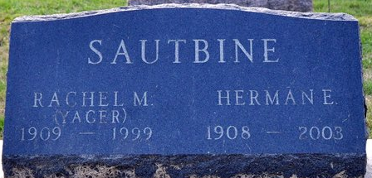
Photo by Deb Curry

Rachel M. Sautbine, 89, retired Portland businesswoman, died at 11:10 p.m. Monday at Swiss Village in Berne. She and her husband, Herman E., had resided in Berne since 1992 after being in business in Portland for many years. She was co-owner of Oakwood Mobile Home & Sales and Sautbine Specialties Parts & Skirting Co. in Portland and was a member of the Portland Business Women's Organization.
Mrs. Sautbine was a member of Trinity United Methodist Church in Berne.
She was born in French Township, Adams County, on Sept,. 12, 1909 to William and Lucinda E. Hocker Yager. Her marriage to Herman E. Sautbine took place on April 14, 1928 at Craigville.
Surviving besides the husband are three sons, William A. of Seattle, Wash., Lester H. of Portland and Ernie Y. of Fishers; a daughter, Mrs. Russell (Dorcas E.) Plumley of Monroeville; two brothers, Samuel H. Yager of rural Berne and Kenneth W. Yager of Fort Wayne; 13 grandchildren; and 19 great-grandchildren. Five brothers and a sister are deceased.
Services at 10:30 a.m. Saturday will be at Yager-Kirchhofer Funeral Home in Berne, where calling hours are today from 3 to 5 and 6 to 8 p.m. and on Saturday from 9 a.m. until time for services.
Rev. Gary Hall will officiate and burial will be in Decatur Cemetery.
Memorials to Trinity United Methodist Church or to the Mission Aviation Fellowship at Redlands, Calif.

Bluffton News-Banner, Wells County, Indiana
Unknown date

**
Rachel M. Sautbine, 89, of Berne, a member of Trinity United Methodist Church, died Monday, March 15, 1999, in Berne. The Adams County native was the co-owner of Oakwood Mobil Home and Sales and Sautbine Specialties Parts and Skirting Company and a member of Portland Business Women's Organization.
Surviving is her husband, Herman; sons William of Seattle, Lester of Portland, Ind., and Ernie of Fishers; daughter Dorcas E. Plumley of Monroeville; brothers Samuel Yager of Berne, and Kenneth Yager of Fort Wayne; 13 grandchildren; and 19 great-grandchildren.
Services are 10:30 a.m. Saturday at Yager-Kirchhofer Funeral Home, Berne, with calling from 3 to 5 p.m. and 6 to 8 p.m. Friday, and one hour prior to services. Burial will be in Decatur Cemetery.
Memorials are to Trinity United Methodist Church or Mission Aviation Fellowship.
News-Sentinel, Allen County, Indiana
Wednesday, March 17, 1999

